Botany Review
Plant Families:
Why is it important to be able to identify what family a plant is in?

Describe the distinguishing characteristics of the following plant families, and give an example of a plant form each:
- Solanaceae
- Lamiaceae
- Roseaceae
- Asteraceae
- Liliaceae
- Apiaceae
- Fabaceae
- Malvaceae
What are the 5 requirements to be a fungus?

How do fungus reproduce?

What are hyphae and mycelium?

Lichens are a symbiotic organism consisting of what two types of organisms?
How do fungus get nutrients?

Label all the parts of the flower.

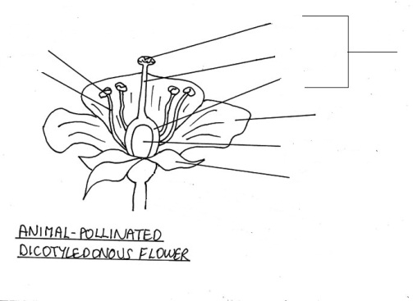
A..

List the functions of each of the parts:
Stamen:
Anther:
Filament:
Pistil:
Stigma:
Style:
Ovary:
Ovule:
Petal:
Sepal:

Compare and contrast pollination and fertilization.

What is a heterotroph? Give an example.

What is an autotroph? Give an example.

What is the problem statement for your project?

Give an explanation of what you are going to be doing in your project.

How can plants protect themselves from herbivores (plant eating animals.)

What adaptations have plants developed to conserve water in hot dry climates?

Give an example of how a plant might camouflage itself from predators, other that the living stones.

Describe how a plant has adapted to survive in an extreme environment: Be sure to describe the environment and the adaptation.

What is natural selection and how might it lead to plants developing new characteristics?

Name 5 plants and their adaptations that can be seen here on the SFCC campus.

